Rodrigo Brasil 09/2023

### **Part 1: Staging two networks**

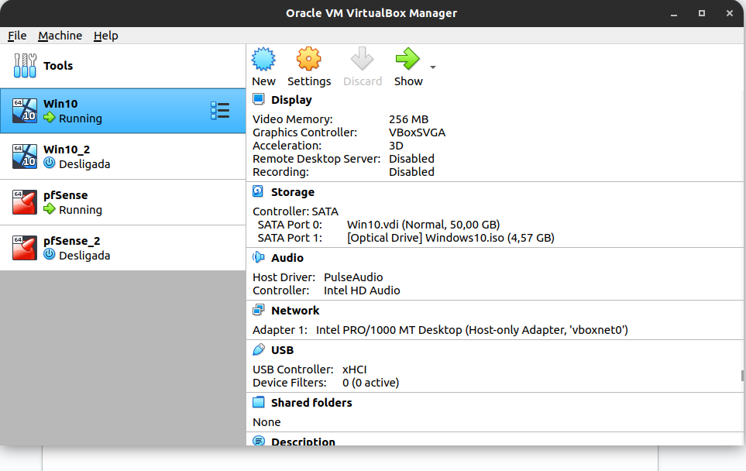

The VM’s, 2 Windows10 machines & 2 pfSense machines.

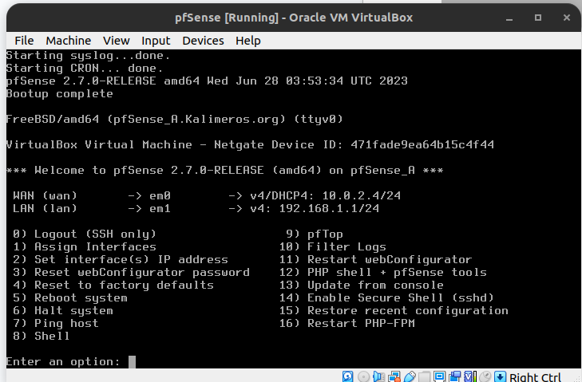

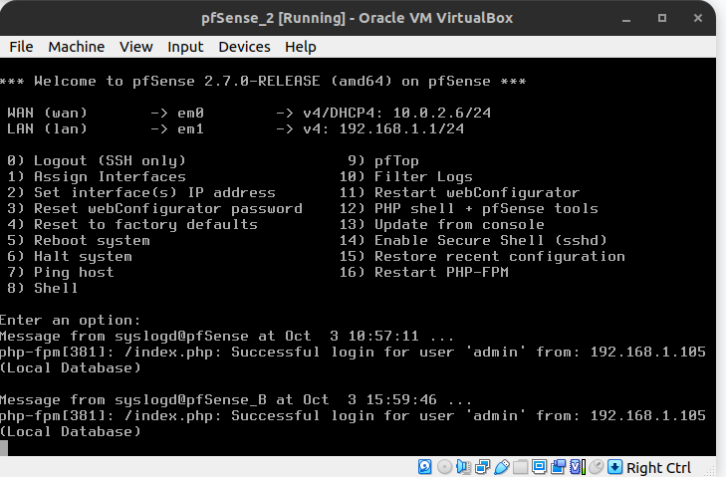

VM pfsense 1 VM pfsense 2

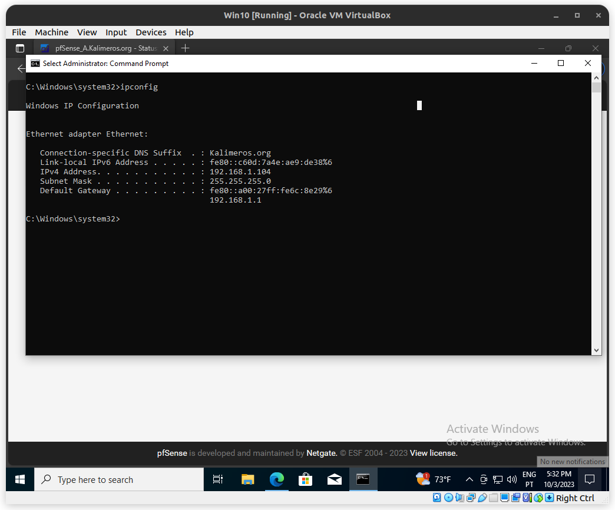

Windows 10 VM 1 with the ip 192.168.1.104

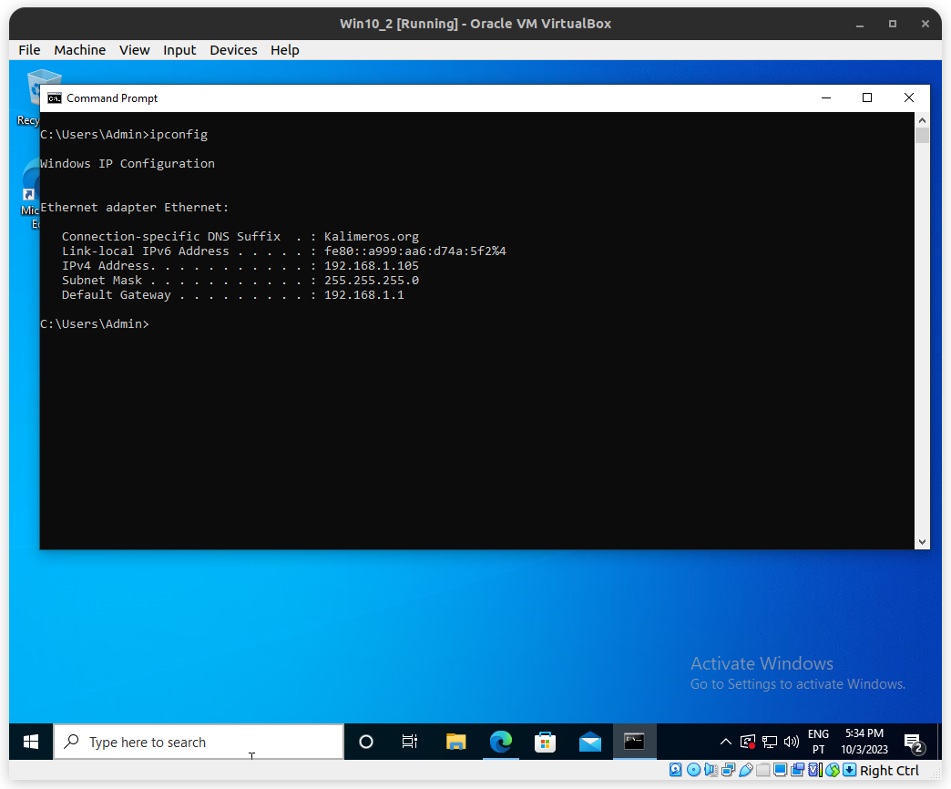

Windows 10 VM 2 with the ip 192.168.1.105

### **Part 2: Configuring pfSense**

* Navigate to Interfaces > WAN, and scroll to the bottom
* Uncheck the boxes for “Block private networks and loopback addresses” and “Block bogon networks”

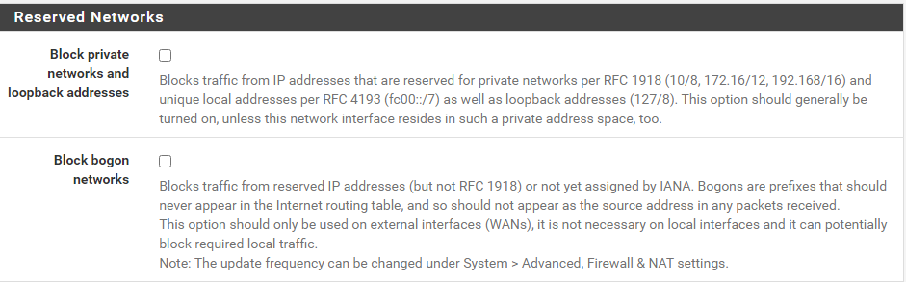

pfSense 1

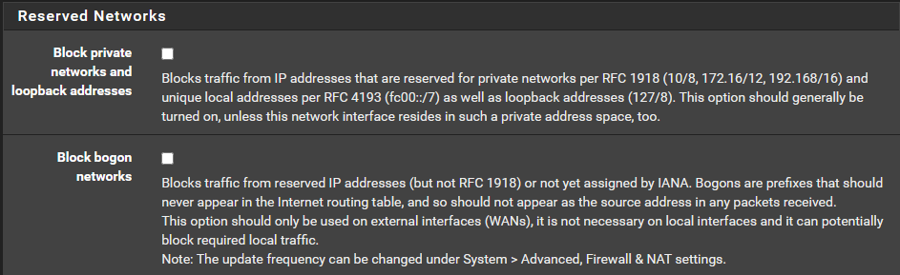

pfSense 2

* Navigate to VPN > IPsec, then select then Advanced Settings tab
* Set IKE SA, IKE Child SA, and Configuration Backend to Diag
* Set all other log settings to Control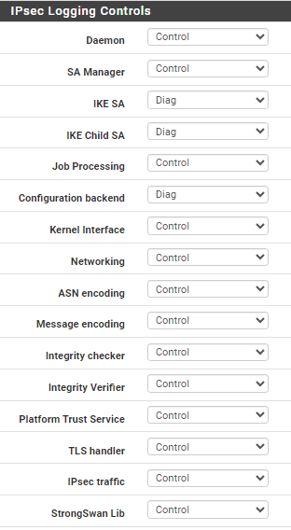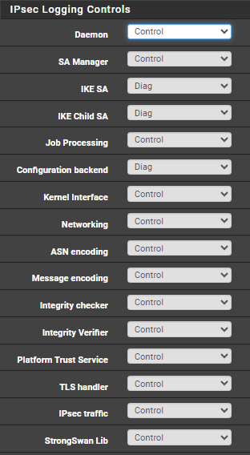

pfSense 1 pfSense 2

**Phase 1**

* Protocol: IKEv2
* Interface: WAN
* Remote Gateway: the WAN IPv4 address of the other router
* Method: Mutual PSK (Preshared Key)
* Encryption: AES 256-bit
* Lifetime: 28800 sec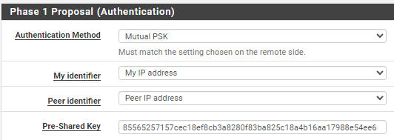

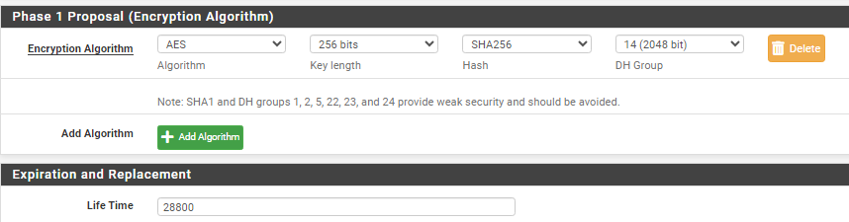

pfSense 1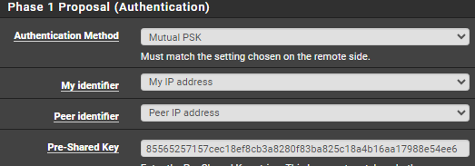

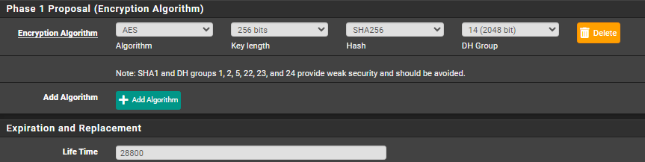

pfSense 2

**Phase 2**

* Mode: Tunnel IPv4
* Local Network: LAN subnet
* Remote Network: the the *subnet address* of the LAN on the other router
* Protocol: ESP
* Encryption: AES 256-bit
* PFS Key Group: 14 (2048 bit)
* Lifetime: 3600 sec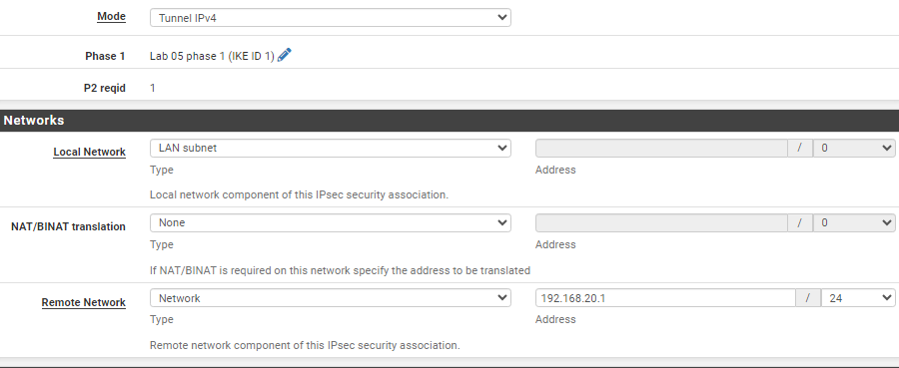

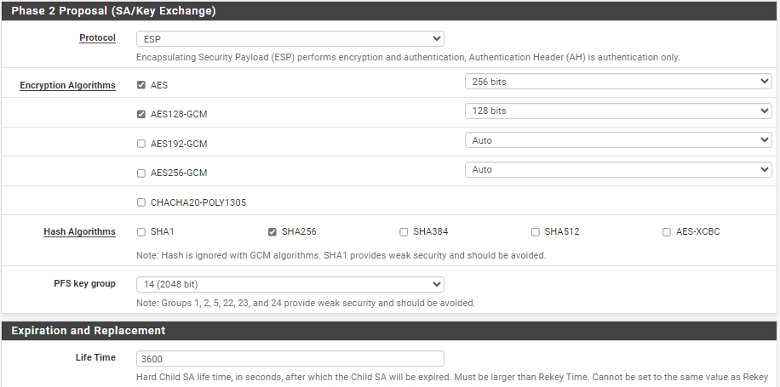

pfSense 1

pfSense 2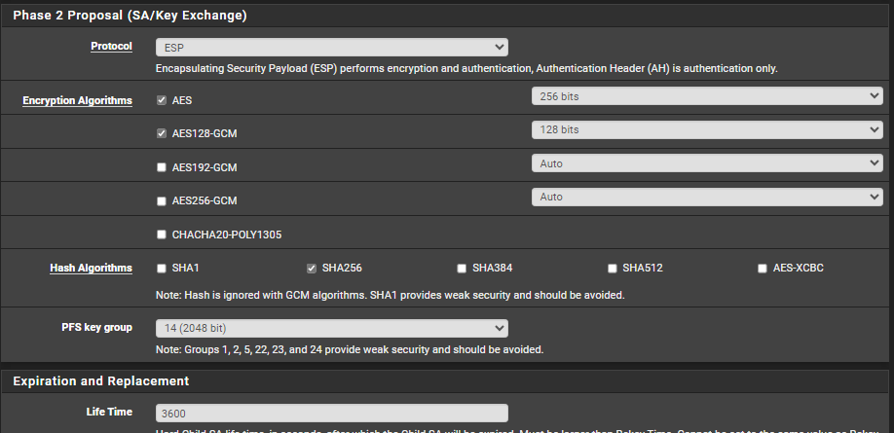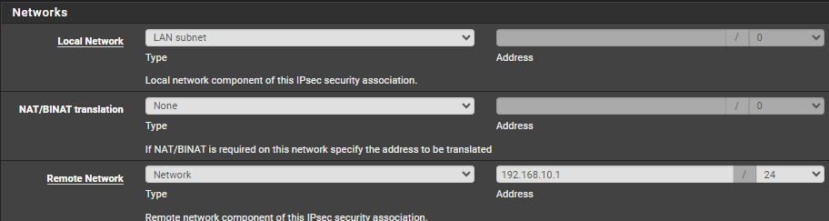

Create corresponding rules on WAN and IPsec:

* Action: Pass
* Protocol: Any
* Source: Any
* Destination: Any

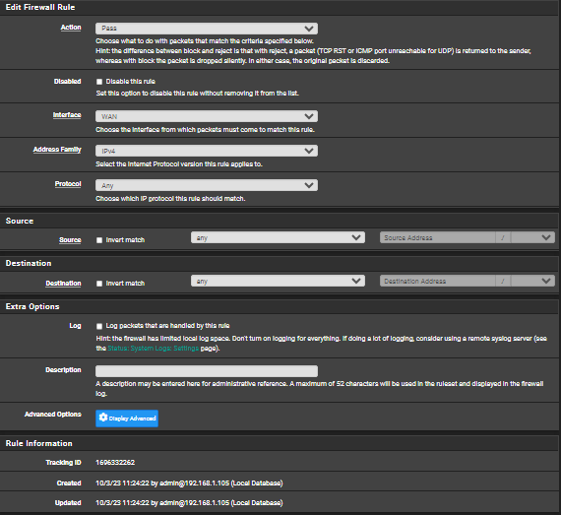

pfSense 2 WAN

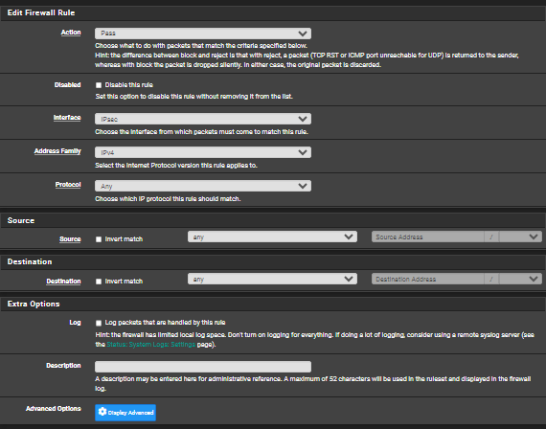

pfSense 2 IPsec

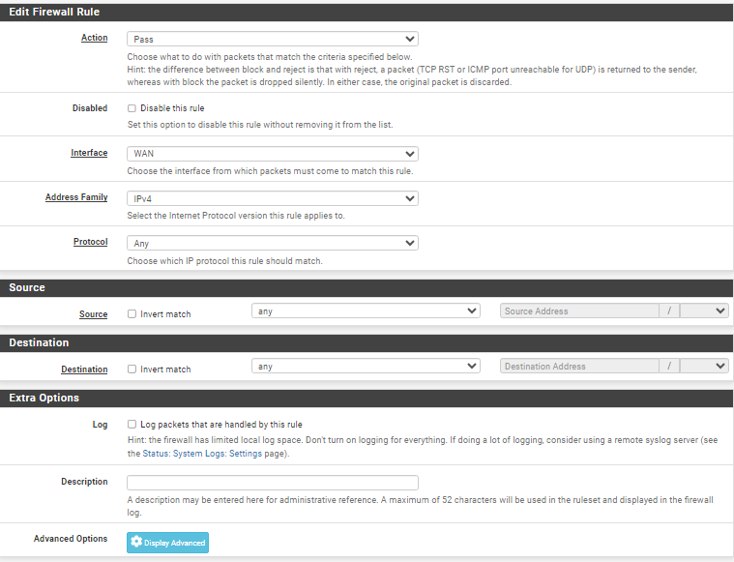

pfSense 1 WAN

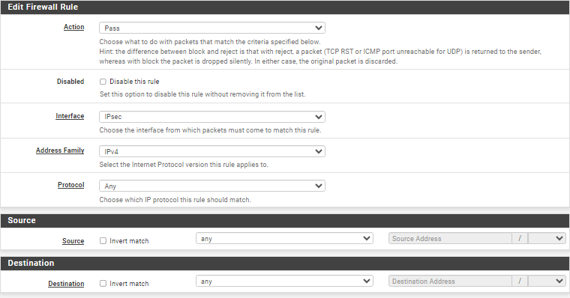

pfSense 1 IPsec

* Navigate to Status > IPsec
* Press “Connect P1 and P2”
* The status screen should indicate “Established” for P1 and “Installed” for P2

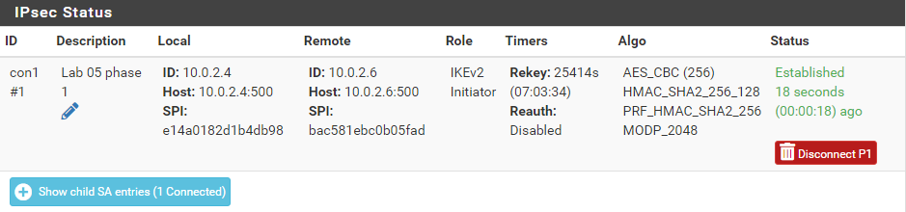

pfSense 1

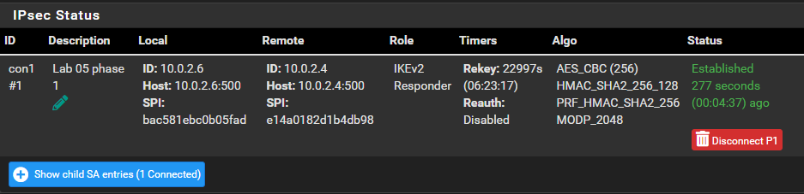

pfSense 2

* Navigate to Diagnostics > Ping
* Hostname: the LAN IPv4 address of the other router
* Source Address: LAN

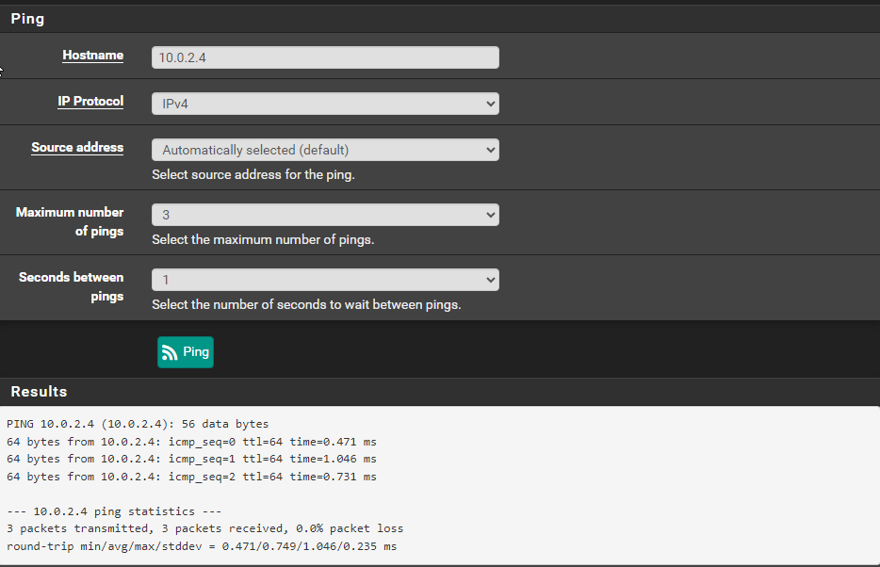

pfSense 2

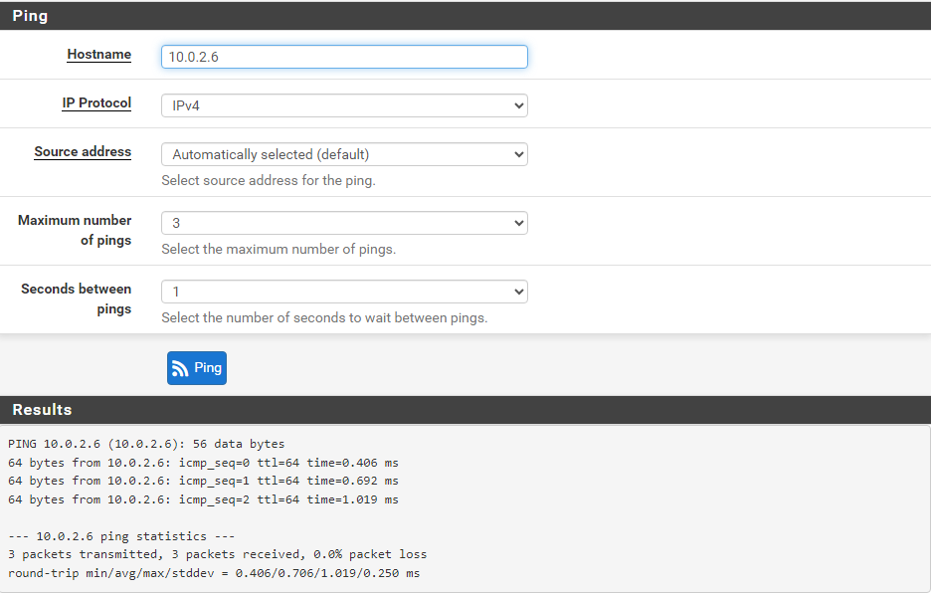

pfSense 1

From a host computer, use the terminal ping command as you normally would.

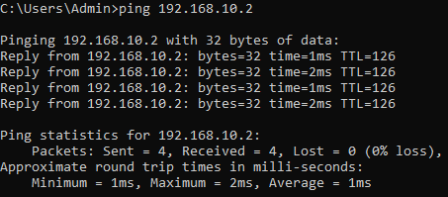

Windows10VM 1 to Windows10VM 2

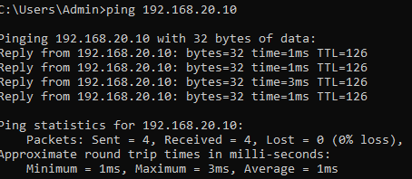

Windows10VM 2 to Windows10VM 1

### **Part 3: Topology**

For each device on the network, include:

